Auto loading using composer

1. Firstly we create out root project folder then a sub folder create in it name src also php extension file called index.php Inside on src folder create out main file what is hold our it can class any name.

As:

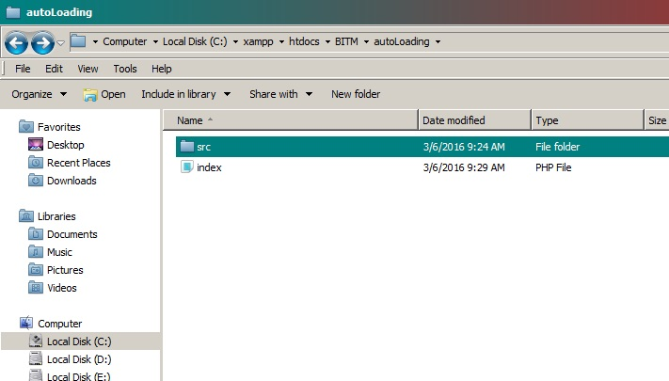

1. Now we have to describe our class as we want, what is in src folder project source file let myproject.php file.

Example:

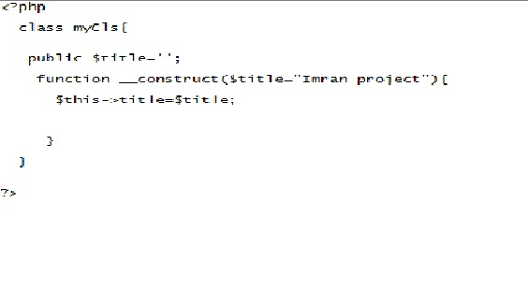

1. Now we include our main project file with in index.php and then we can access from here our myproject.php file.

As:

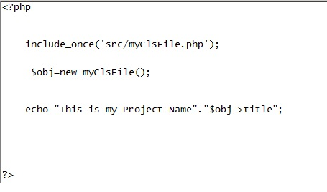

1. In this step we working with namespace hence we include our main project file or source project what is myProject.php with a namespace, for this process defined as namespace keyword and a name.

like as:

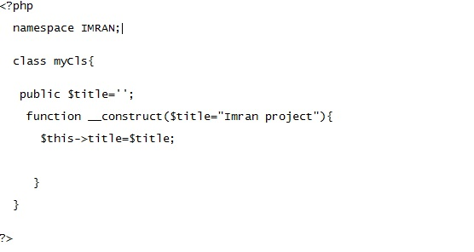

1. Now we have to change our index.php include path, because we make a namespace for our project:

As:

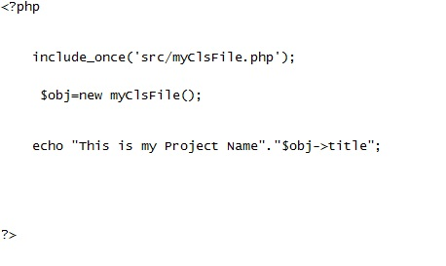

1. We cane include our necessary file two way define user function and using composer tools.

For composer system we need to downloaded the composer tool from here [**https://getcomposer.org/download/**](https://getcomposer.org/download/)then we install the tool for use.